**Step 1) Copy following code for dropdowns and textboxes in "customer_payments.php"**

start_row();

wth_tax_type_list_cells(_("WHT Supply Tax"), 'wht_supply_tax', null,

_("Select Tax Type"), true,null,null,1);

hidden('wht_supply_percent', $_POST['wht_supply_percent']);

amount_cells(_("WHT Supply Amount :"), 'wht_supply_amt');

end_row();

start_row();

wth_tax_type_list_cells(_("WHT Service Tax"), 'wht_service_tax', null, _("Select Tax Type"), true,null,null,2);

hidden('wht_service_percent', $_POST['wht_service_percent']);

amount_cells(_("WHT Service Amount :"), 'wht_service_amt');

end_row();

start_row();

wth_tax_type_list_cells(_("WHT FBR Tax"), 'wht_fbr_tax', null, _("Select Tax Type"), true,null,null,3);

amount_cells(_("WHT FBR Amount :"), 'wht_fbr_amt');

end_row();

start_row();

wth_tax_type_list_cells(_("WHT SRB Tax"), 'wht_srb_tax', null,

_("Select Tax Type"), true,null,null,4); //asad

amount_cells(_("WHT SRB Amount :"), 'wht_srb_amt');

end_row();

amount_row(_("Write Off : "), 'discount');

$display_discount_percent = percent_format($_POST['pymt_discount']*100) . "%";

hidden('gst_wh', $_POST['gst_wh']);

amount_row(_("Total Amount:"), 'amount', null, " class='tableheader2' ");

hidden('amount_new',$_POST['amount_new']);

textarea_row(_("Memo:"), 'memo_', null, 22, 4);

submit_cells('get_final_amount',"Calculate",null,null,true);

end_table(1);

//--------------end-------------------------

**Step 2) Copy and paste following code for sending values in textbox through dropdown in "customer_payments.php"**

if(list_updated('wht_supply_tax'))

{

$percentage = get_wht_tax_percentage(get_post('wht_supply_tax'));

$_POST['wht_supply_amt'] = price_format($percentage) /100 * input_num('amount');

$Ajax->activate('wht_supply_amt');

}

if(list_updated('wht_service_tax'))

{ $percentage = get_wht_tax_percentage(get_post('wht_service_tax'));

$_POST['wht_service_percent'] = price_format($percentage);

$_POST['wht_service_amt'] = price_format($percentage) /100 * input_num('amount');

$Ajax->activate('wht_service_percent');

$Ajax->activate('wht_service_amt');

}

if(list_updated('wht_fbr_tax'))

{ $percentage = get_wht_tax_percentage(get_post('wht_fbr_tax'));

$_POST['wht_fbr_percent'] = price_format($percentage);

$Ajax->activate('wht_fbr_percent');

$Ajax->activate('wht_fbr_amt');

}

if(list_updated('wht_srb_tax'))

{$percentage = get_wht_tax_percentage(get_post('wht_srb_tax'));

$_POST['wht_srb_percent'] = price_format($percentage);

$Ajax->activate('wht_srb_percent');

$Ajax->activate('wht_srb_amt');

}

**Step 3)copy and paste following function in customer_payments.php file for calculation button**

if(isset($_POST['get_final_amount'])) {

$Ajax->activate('amount');

$_POST['amount']=$_POST['amount_new'];

}

**Step 4)** **copy following code for dropdown in (ui_lists .php) for creating dropdown**

function wth_tax_type_list($name, $selected_id=null, $special_option=false, $submit_on_change = false,

$enabled=false, $level_id = 0,$id)

{

$sql = "SELECT `id`, `description`,CONCAT(co_account,' -',tax_percent) FROM `".TB_PREF."wth_tax_types` where wth_tax_category = $id ";

$where = $enabled ? array("level_id =".$level_id, ) : array();

return combo_input($name, $selected_id, $sql, 'id', 'description',array(

'spec_option' => $special_option===true ? ' ' : $special_option,

'order' => 'description',

'where' => $where,

'spec_id' => 0,

'format' => '_format_wth_tax_type',

'select_submit'=> $submit_on_change,

));

}

function wth_tax_type_list_cells($label, $name, $selected_id=null, $special_option=false, $submit_on_change = false, $enabled=false, $level_id = 0,$id)

{

if ($label != null)

echo "<td>$label</td>\n";

echo "<td>";

echo wth_tax_type_list($name, $selected_id, $special_option, $submit_on_change, $enabled, $level_id,$id);

echo "</td>\n";}

function wth_tax_type_list_row($label, $name, $selected_id=null, $special_option=false, $submit_on_change = false, $enabled=false, $level_id = 0)

{ echo "<tr><td class=''>$label</td>";

wth_tax_type_list_cells(null, $name, $selected_id, $special_option, $submit_on_change, $enabled, $level_id);

echo "</tr>\n";

}

function _format_wth_tax_type($row)

{ return $row[1]." - " .$row[2]."%";

}

**Step 5**) **Import database table given in the folder by name "** **0_wth_tax_types " file in your database**

after you will import table in database all dropdown values will appear in dropdown

Note : you will have a view like this after this completing this step

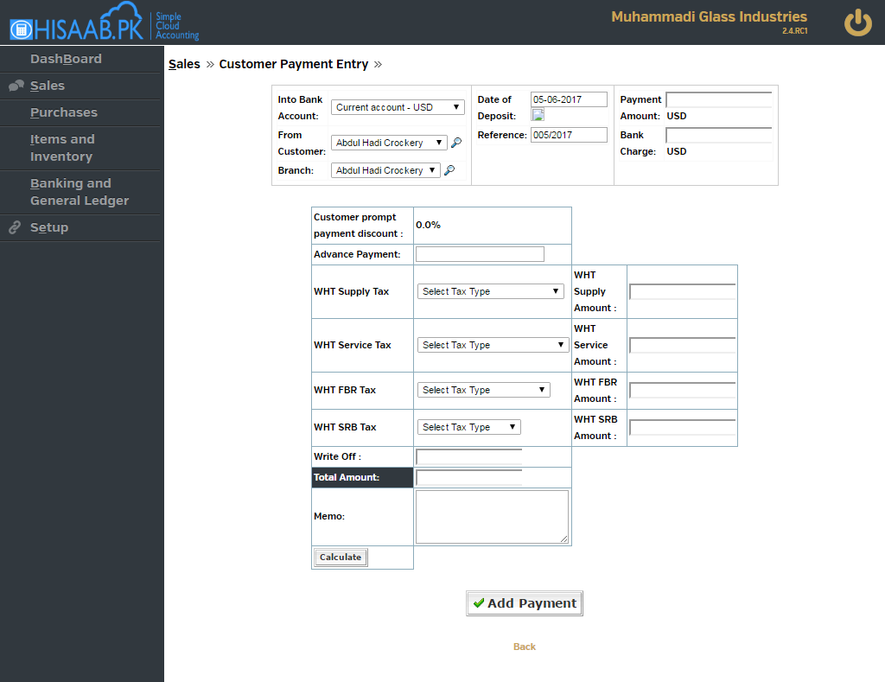

Note: after entering amount in This allocation ,then selecting value from dropdown and then pressing tab you will get calculated amount in textbox

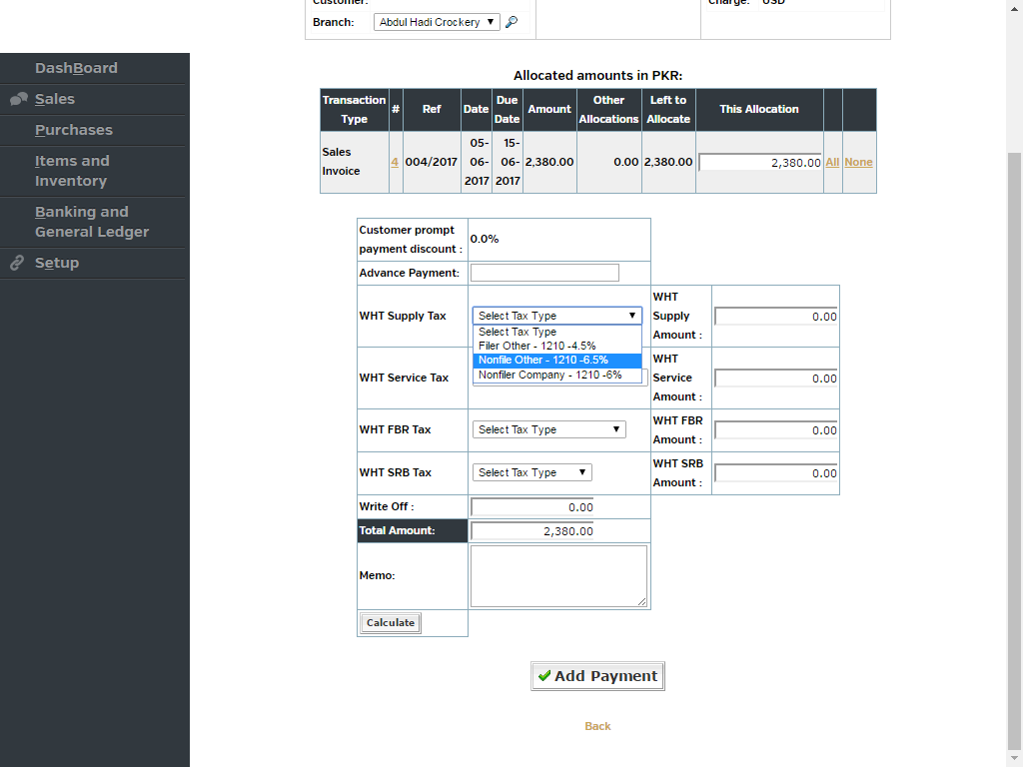

**Step 6 )ADD all dropdown and textbox params in write_customer_payment function**

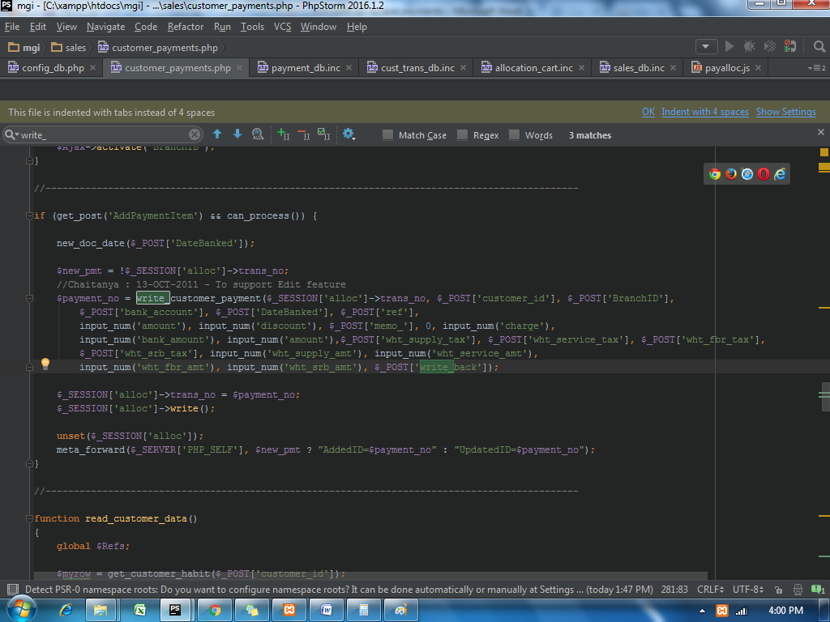

**Step 7)Copy and paste following code for gl trans entry**

if ($supply_disc != 0) { $supply_acc = get_wht_account_code($supply_tax_id);

/* Now Debit discount account with Supply discounts allowed*/

$total += add_gl_trans_customer(ST_CUSTPAYMENT, $payment_no, $date_,

$supply_acc, 0, 0, $supply_disc, $customer_id,

"Cannot insert a GL transaction for the payment discount debit");

}

if ($service_disc != 0) {

/* Now Debit discount account with Service discounts allowed*/

$service_acc = get_wht_account_code($service_tax_id);

$total += add_gl_trans_customer(ST_CUSTPAYMENT, $payment_no, $date_,

$service_acc, 0, 0, $service_disc, $customer_id,

"Cannot insert a GL transaction for the payment discount debit");

}

if ($fbr_disc != 0) {

/* Now Debit discount account with FBR discounts allowed*/

$fbr_acc = get_wht_account_code($fbr_tax_id);

$total += add_gl_trans_customer(ST_CUSTPAYMENT, $payment_no, $date_,

$fbr_acc, 0, 0, $fbr_disc, $customer_id,

"Cannot insert a GL transaction for the payment discount debit");

}

if ($srb_disc != 0) {

/* Now Debit discount account with SRB Discount allowed*/

$srb_acc = get_wht_account_code($srb_tax_id);

$total += add_gl_trans_customer(ST_CUSTPAYMENT, $payment_no, $date_,

$srb_acc, 0, 0, $srb_disc, $customer_id,

"Cannot insert a GL transaction for the payment discount debit");

}

if($write_back != 0){

$total += add_gl_trans_customer(ST_CUSTPAYMENT, $payment_no, $date_,

$write_back_account, 0, 0, -($write_back), $customer_id,

"Cannot insert a GL transaction for the GST WH");

}

**Step 7)**

ADD all dropdown and textbox params in write_customer_trans function in Payment_db.inc

after adding params to the function pass the params in insert query of that function which will be of debtor_trans table

**Step 8)Following steps are to create setup form of WTH Tax Types**

Copy and paste wht_type.php file in sales/ manage path and wht_types_db.inc file in sales/includes/db path ,Both the files are in the wth on payments folder

after that include the file wht_type.php in applications/customers file

**Step 9) Copy and paste following code in ui_lists.php**

**//-------------**

function wht_tax($name, $selected_id=null, $supply_tax="", $service_tax="", $fbr_tax="", $srb_tax="", $submit_on_change=false)

{$items = array();

$items['1'] = strlen($supply_tax) ? $supply_tax : _("WHT Supply Tax");

$items['2'] = strlen($service_tax) ? $service_tax : _("WHT Service Tax");

$items['3'] = strlen($fbr_tax) ? $fbr_tax : _("WHT FBR Tax");

$items['4'] = strlen($srb_tax) ? $srb_tax : _("WHT SRB Tax");

return array_selector($name, $selected_id, $items,

array(

'select_submit'=> $submit_on_change,

'async' => false ) ); // FIX?

}

function wht_tax_list_cells($label, $name, $selected_id=null, $name_yes="", $name_no="", $submit_on_change=false)

{

if ($label != null)

echo "<td>$label</td>\n";

echo "<td>";

echo wht_tax($name, $selected_id, $name_yes, $name_no, $submit_on_change);

echo "</td>\n";

}

function wht_tax_list_row($label, $name, $selected_id=null, $name_yes="", $name_no="", $submit_on_change=false)

{

echo "<tr><td class=''>$label</td>";

wht_tax_list_cells(null, $name, $selected_id, $name_yes, $name_no, $submit_on_change);

echo "</tr>\n";

}